Person Centred Risk Assessment Policy

Identifying and evaluating risk is an essential part of support planning and managing health and safety. Risk assessment is about identifying hazards and estimating the degree of risk related to a particular activity or behaviour. Risk assessing with and for people is not an exact science and it is important that the quality of a person’s life should not be dictated by systems, procedures and actions that are mainly concerned with ‘covering your back’!

There are many things in everyday life that carry some degree of risk. It is about trying to do things as safely and sensibly as we can. It is not about saying that we will only do things that are totally ‘safe’ - nothing is! This process will not come up with a score - it should come up with common sense and a respect for what people want to do in their life.

When thinking about assessing risk it is important to make sure that the right people are present at the session. In general, the more sensitive the decision the more important the consultation is.

Risk assessment should not be a quick procedure, nor a paper-based, form-filling exercise. It should be used as a group process and should be a dynamic, problem-solving and consensus-building. It must be qualitative, designed to fully explore the risk, problem solve around it and come up with strategies which balance the safety, wellbeing and happiness of the person concerned.

Person-centred planning approaches should be used to identify what is important to a person from their perspective and find appropriate solutions. Enabling our people to exercise choice over their lives, and therefore the management of risk, is central to achieving better outcomes for them.

Even when good person centred approaches are used, the reality is that if something goes wrong sometimes people may not want to accept responsibility and will look for someone else to blame. It is therefore vital to keep accurate records of discussions that take place about areas of choice. Such documentation may be critical in order to protect the person in making choices as well as the position of support providers in the event of any complaints or litigation.

The person themselves is the best judge of when they feel safe or unsafe and we must remember that the person’s story belongs firstly to them and is not the property of professionals or anyone else. It is unlikely that people will discuss their real feelings of safety or danger with a stranger or fill in a form about something so personal, so the form is designed to be very accessible and a clear process for assessing risk. It also considers what opportunities might be lost.

The format will work best if every effort is made to include the person and as many people as possible who are involved in their circle of support. It is possible, though, that this could produce disagreement, as there may be different attitudes to risk and to what an individual is capable of or should be doing. If this happens, it is important that every effort is made to ensure that what the person wants to do is not blocked by one party, they have a right to citizenship, inclusion and support in balancing their safety, wellbeing and happiness.

Guidance notes and suggested questions for undertaking person centred risk assessments

Who is the person?
What would they like to do/try/achieve?
Why would this be a good thing to do? Why do they want to do it?

When you answer the next two questions, think about whether someone could be injured, something damaged, or whether someone could be embarrassed. Keep this clear. Keep this to things that you know have happened before or things that are likely to happen - and use common sense.
What is likely to go wrong or what could spoil this?
Is there anything that could be dangerous?
What can the person do to make this safer?

What could other people do to help them make this safer?

Having thought about this and if we do what we have said we would do, does this feel like it is a safe thing to do?

Identifying the risk and why it is something that someone wants to do
What is the risk? What are you talking about? It might be something that someone wants to do, or it might be perceived challenging behaviour that needs to be managed in order that someone can do something. Firstly, be clear that it is a part of our role to support it. Is it part of our role and nobody else’s, or is it something that other people will be involved in?

Consequences! What Will Happen?
Think about possible injury or damage, but also think about how the person might be perceived; think about any effect on others, like members of the public. How might it affect people’s perception of the individual? Could this have a negative effect for other people? Keep this realistic - keep it clear - keep it precise. Use common sense and do not go off on ‘flights of fancy’ about what might happen!

Occurrence - Where and When?
Does the risk happen at a particular place or a particular time?
If it is a risk related to behaviour, is there something else going on around that time or place that might be making this happen, or making it worse? Are there any clues that it might be about to happen?

It might have happened once - is it realistically likely to happen again or was there a particular reason that time? Is that reason likely to recur or can it be avoided? We all make mistakes! We all have a responsibility to empower and encourage our individuals to ‘move on’. Base all of these thoughts and discussions on things that have actually happened and then use that to inform any prediction about what might happen in the future.

Strategies to Reduce and Manage the Risk
This is where you need to share thoughts and ideas. Think of the obvious and the not-so-obvious. Think ‘out of the box’. Be creative - sometimes solutions or improvements will be really simple.

What is important here is to not ‘give-up’ because you have identified some risks! You have set yourselves a puzzle, or challenge! You have to try and find the answers, but they have to be realistic and responsible answers that are based on common sense and evidence.

The Missing Bit!
Many risk assessment processes will miss this bit - the balance!
We would all get pretty miserable if people kept telling us we could not do things because something might go wrong. We owe it to the people we support to take a responsible attitude - but we also owe it to them to support them to have as fulfilled a life as possible.
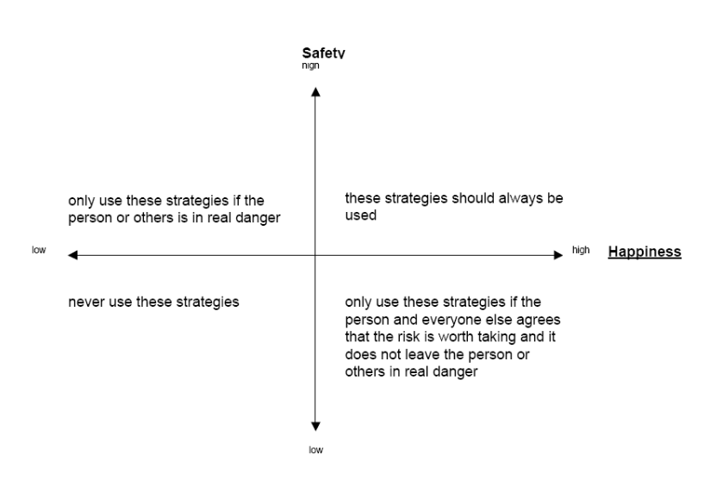
You could use this simple graph to measure your strategies against.

By Now You Should Have:
Become clear about what the issue or risk is and about when, and maybe why, it happens. Understand the potential consequences of the issue.
Considered carefully the potential opportunity lost and what is important to the person. Devised strategies to reduce or manage the risk. Considered carefully those strategies and the balance between safety (of the person and others) and their happiness. Decided which strategy or strategies, you will adopt. Decided what records you need to keep and when you need to review what you have decided.

It is important that if after working through this process you are still unable to come up with a strategy that you are happy with, that you go back to basics around what the person wants to do and see if there are other ways of approaching it that will come close to meeting the same wishes. For instance, someone wants to drive. You cannot agree that they would be safe on the open road. Maybe that person could drive a quad bike off-road or a go-cart or even a grass-track racer. Maybe they want to be close to vehicles and could help out with a grass track team or work in a garage, which might meet most of the need.

Always ask for help from family members, senior staff and managers. We need to work together to produce the best outcomes for each individual!

These guidelines and the questions to ask are based on ‘Person Centred Risk Assessment’ by Peter Kinsella, Paradigm, ‘Balancing Safety & Happiness’ (Marshfield) and the Our Health, Our Care, Our Say White Paper 2005.

